Multipurpose Security and Surveillance Mission Platform (1992-1998)

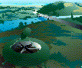
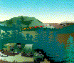
The Multipurpose Security and Surveillance Mission Platform (MSSMP), started in FY'92 as the Air-Mobile Ground Security and Surveillance System (AMGSSS), is designed to provide a rapidly deployable, extended-range surveillance capability for a variety of operations and missions, including: fire control, force protection, tactical security, support to counterdrug and border patrol operations, signal/communications relays, detection and assessment of barriers (i.e., mine fields, tank traps), remote assessment of suspected contaminated areas (i.e., chemical, biological, and nuclear), and even resupply of small quantities of critical items. The MSSMP system consists of three air-mobile remote sensing packages and a base station.
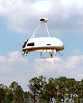
MSSMP system requirements include:
- High mobility,
- Remote operations over low-bandwith tactical radio links,
- Long-endurance surveillance capabilities, and
- The ability for one operator to supervise several remote systems.

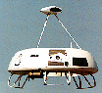
The MSSMP sensor packages may operate as portable stand-alone units, or from air-mobile platforms. The current design of the air-mobile platforms is based on the Sikorsky Cypher enclosed-rotor vertical-take-off-and-landing unmanned air vehicle. This air-mobile platform carries its sensor package from one ground surveillance location to another, up to 10 km from the base station.
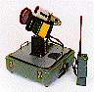
Each sensor package is mounted on a pan-and-tilt unit, and includes:
- Visible light video camera
- Infrared video camera
- Laser range finder
In addition, a link is provided for an optional portable acoustic sensor.
To keep radio activities to a minimum, most sensor processing is performed by the remote payload. Acoustic and visual motion detection is used to detect, identify, and locate targets of interests. Preprogrammed responses are activated upon detection and may include only an alert to the operator, or automatic transfer of a static image, laser range or an image stream.
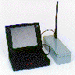
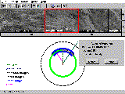
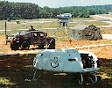
For the prototype unit, the operator's control display station is a laptop computer running a graphical Windows program. All commands to the remote sensors are initiated using the built-in keyboard and pointing device. All data and images sent back are displayed on the laptop's color monitor. Communication between all remote payload subsystems and the control/display station uses a fully connected Ethernet TCP/IP radio network with autorelaying capability.
Development of the MSSMP system is on-going. A portable mission payload prototype package has been developed by a team of NRaD engineers and scientists, and an additional payload package has been integrated onto the Cypher vehicle by Sikorsky and NRaD engineers. In May 1996, the system was successfully demonstrated at the Military Police School at Ft. McClellan, AL, in a simulated counter-drug operation. The man-portable sensor package mounted on a ground vehicle-of-opportunity and the Cypher-mounted sensor package were operated simultaneously over the same radio network.

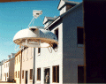
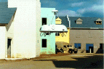
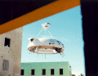
In January 1997, the MSSMP system's expanded role was demonstrated in a Military Operations in Urban Terrain scenario at the Dismounted Battlespace Battle Laboratory, Ft. Benning, Georgia. The system demonstrated reconnaissance support with the vehicle flying down city streets, looking through upper- and lower-story windows, providing lookout support ahead of advancing troops, and performing observations after landing on the roof of a two story building. The vehicle also dropped a simulated radio relay on the top of a building, a miniature intrusion detector in an open field, and carried a standard Army laser rangefinder/designator as a payload.
In the second half of 1997, MSSMP spawned another project, MPNSS, focusing on developing ruggedized man-portable sensor packages using the same wireless network architecture.

For a more detailed look at the MSSMP program (and its AMGSSS predecessor), go to the publications below:
- Murphy, D.W., J.P. Bott, W.D. Bryan, J.L. Coleman, D.W. Gage, H.G. Nguyen, and M.P. Cheatham, "MSSMP: No Place to Hide," AUVSI'97, Baltimore, MD, 3-6 June, 1997. (Program update and user assessment tests)
- Murphy, D.W., J.P. Bott, J.P. Cycon, W.D. Bryan, J.L. Coleman, D.W. Gage, W.C. Marsh, B.F. Martin, H.G. Nguyen, and R. Schneider, "Air-Mobile Ground Security and Surveillance System (AMGSSS) Project Summary Report," Technical Document 2914, NCCOSC RDT&E Division, San Diego, CA; September 1996 (AD-A317618). [PDF (1117 KB)]
- Nguyen, H. G., Marsh, W. C., and W. D. Bryan, "Virtual Systems: Aspects of the Air-Mobile Ground Security and Surveillance System Prototype," Unmanned Systems, Vol. 14, No. 1, Winter 1996. (More detailed description of system architecture, rapid prototyping strategy, and advantages provided by TCP/IP interconnectivity)
- Murphy, D. W. and J. P. Bott, "On the Lookout: The Air Mobile Ground Security and Surveillance System (AMGSSS) Has Arrived," Unmanned Systems, Vol. 13, No. 4, Fall 1995. (Program summary and description of subsystems)
- Martin, B. and D. Bryan, "Low-Cost Miniature Interface and Control Systems for Smart Sensors, Tactical Radios, and Computer Networks," IEEE Military Communications Conference (MILCOM 95), San Diego, CA, Nov. 6-8, 1995. (Various novel uses of technologies and techniques employed by the system)

MPEG Movies

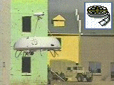
MSSMP providing lookout support for advancing troops (1.4 MB). (Video courtesy of Sikorsky)
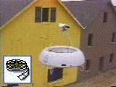
MSSMP performing reconnaissance in urban terrain, looking through upper-story windows (1.3 MB). (Some segments courtesy of Sikorsky)
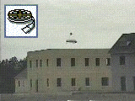
MSSMP landing on top of a building and providing lookout support (1.7 MB). (Video courtesy of Sikorsky)
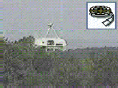
MSSMP Cypher in flight (1.4 MB). Note: If your MPEG player cannot handle larger files, here are the individual segments: taking off (470 KB), cruising (390 KB), and landing (512 KB)

